ÇANKAYA UNIVERSITY



CENG408-Innovative System Design and Development II

THE VISUAL ASSET MANAGEMENT SYSTEM

USER MANUAL

Contents

INTRODUCTION 3

LOGIN 3

FORGOTTEN PASSWORD 4

New User Registration 4

User Authentication 5

CRUD (CREATE READ UPDATE DELETE) FUNCTIONS 6

HOME PAGE -DISPLAYING ASSET 8

LOGOUT 9

# INTRODUCTION

The purpose of this document is describing The Visual Asset Management System for Cankaya University. This system aims to manage school assets and observe these from floor to floor on the web somehow more easily and user friendly. This document elaborate on detailed information about the project. In addition the user manual document explains how users interact with the system for understanding the system clearly. The detailed requirements of the Visual Asset Management System are provided in this document.

# LOGIN

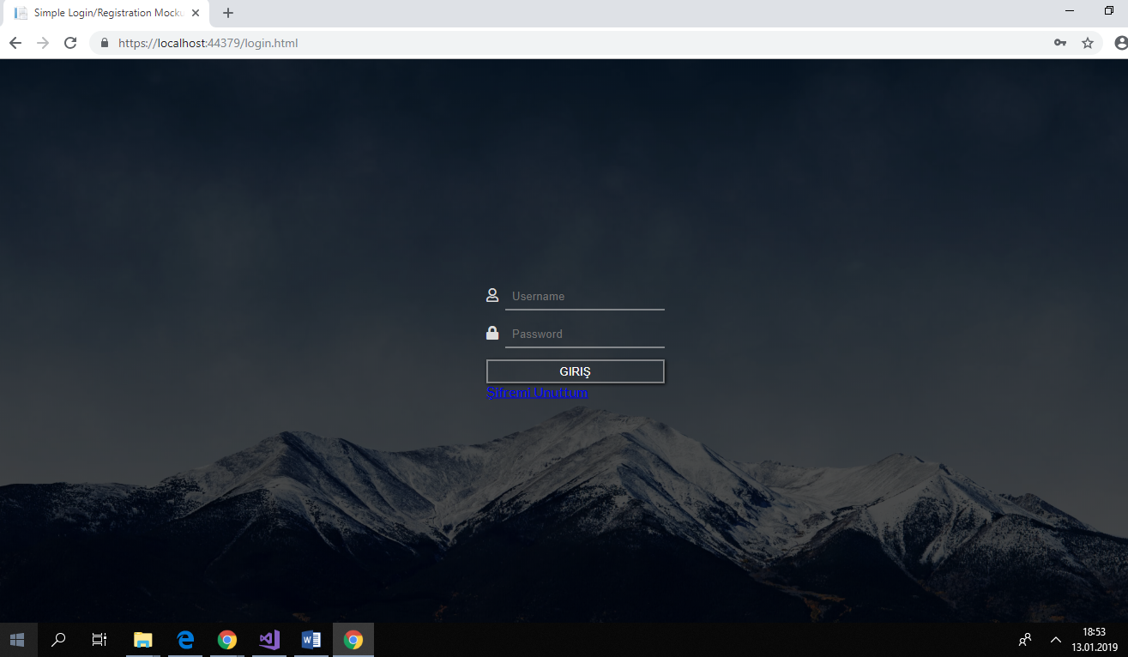

*Figure1:Login Page*

The users who have previously registered for the Visual Asset Management System must login by:

1. Entering their User Name.

2. Entering their Password.

3. Selecting “Giriş” button to go to User Home Page and begin using the application.

# FORGOTTEN PASSWORD

Forgotten Passwords If a user forgets his or her password, he or she must select “Şifremi Unuttum” button to get a new password.

After pressing the button, the new password is automatically sent to the user via e-mail.

# New User Registration

If the user is admin, it is authorized to add new users. Only the Admin user can see the “Kullanıcı” button from the Menu and make changes and registration for the users.

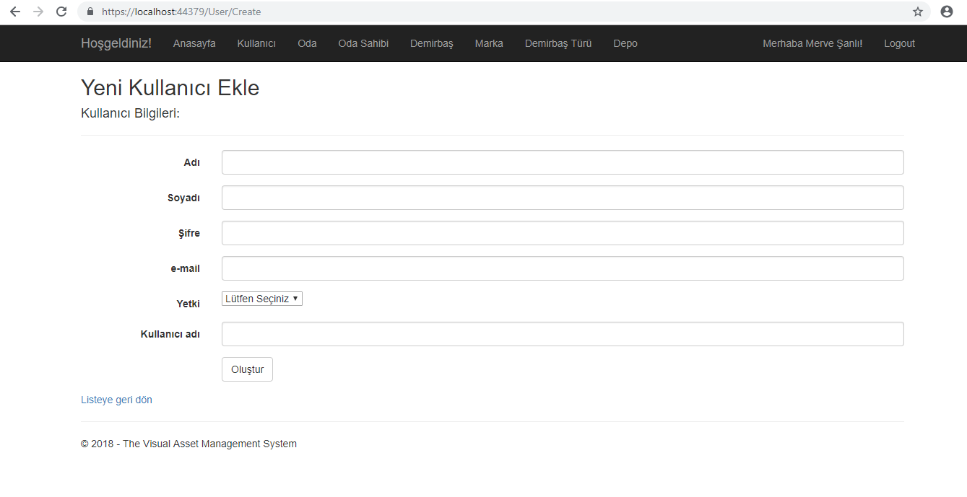

*Figure 2: User Registration Page*

Admin will be asked to enter or select the following information for User Registration

1. Name
2. Surname
3. Password
4. E-mail
5. Authentication(Admin-Staff)
6. Username

Select "Oluştur" to submit the registration information and continue to the next screen.

# User Authentication

The user can be a staff or admin. The menu that both people see and the things they can do vary. Also, shown below are separate menu views for both user and admin.

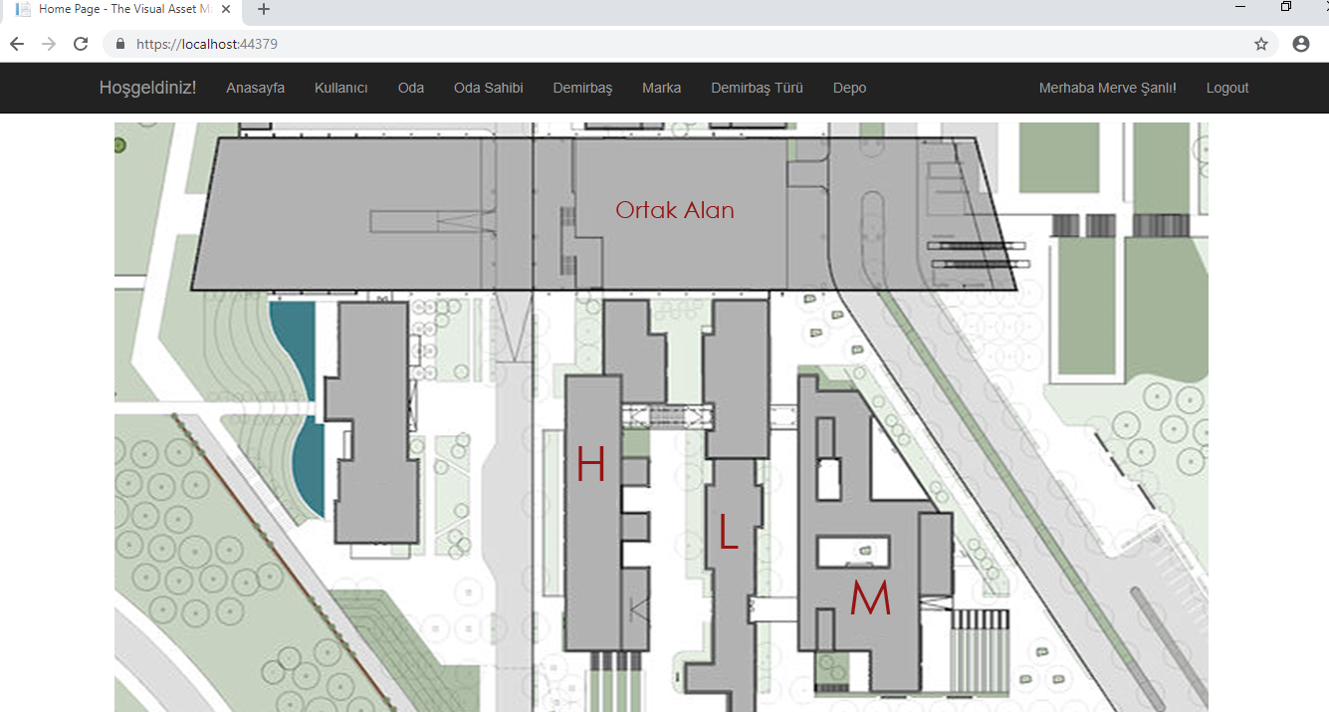

*Figure 3:HomePage for Admin*

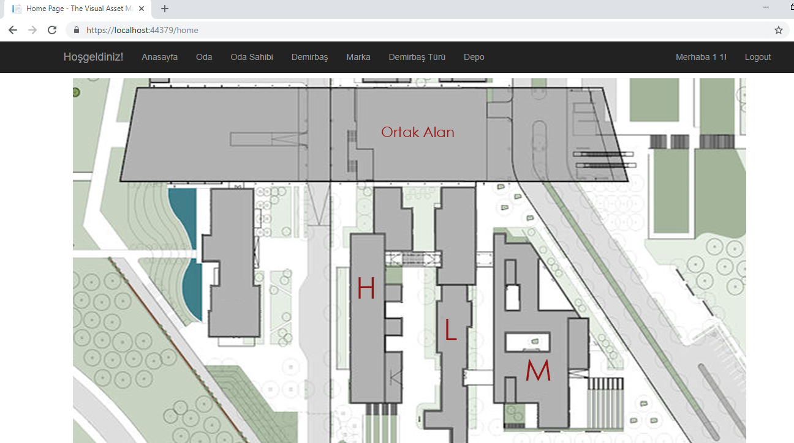

*Figure 4:HomePage for User*

# CRUD (CREATE READ UPDATE DELETE) FUNCTIONS

Only the Admin can make CRUD functions in the Visual Asset Management Systems. Hovewer, only he can update the room name. Because the floor plans in the system are stable.

1. Edit and Delete methods are located next to the list for each button.
2. The Create button is at the top of each list.

(HomePage Buttons:Marka/Kullanıcı/Oda/Demirbaş/Oda Sahibi/Demirbaş Türü/Depo)

An Example of CRUD functions for Brand:

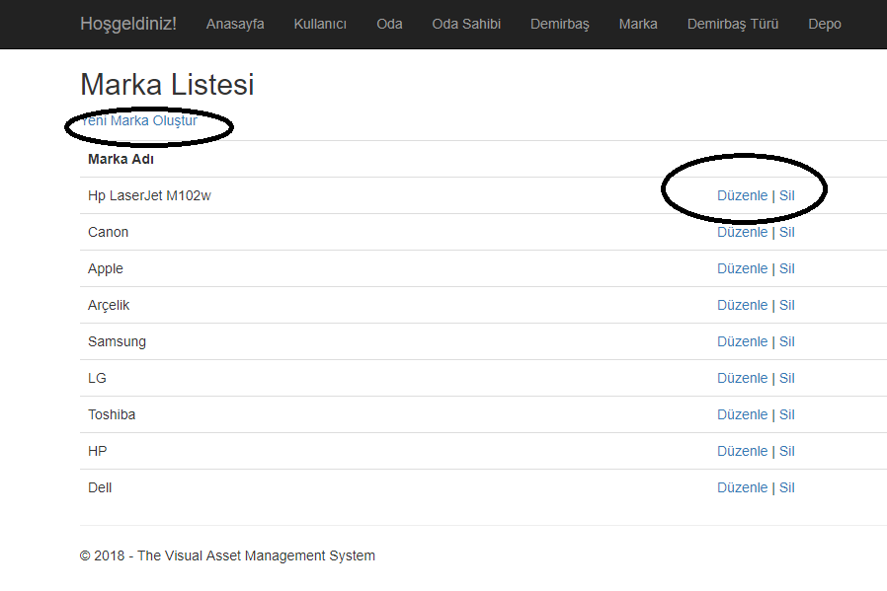

*Figure 5:Brand List*

Create:”Yeni Marka Oluştur” Button

Delete:”Sil” Button

Edit:”Düzenle” Button

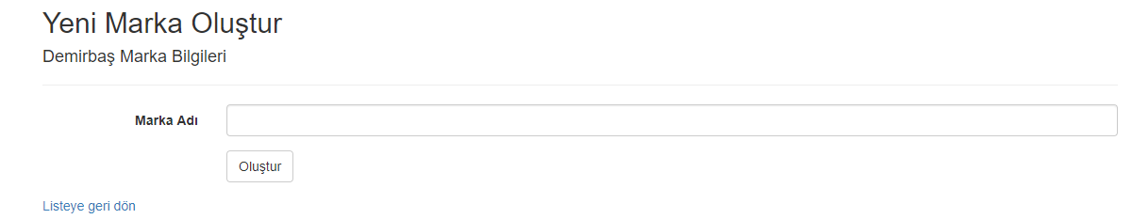

*Figure 6:Create Brand*

Select "Oluştur" to submit the brand information and continue to the next screen.

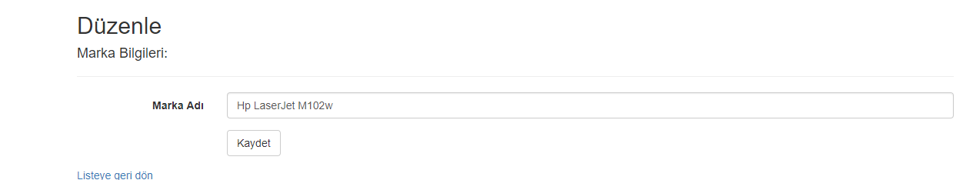

*Figure 7:Edit Brand*

Select "Kaydet" to save the new brand information and continue to the next screen.

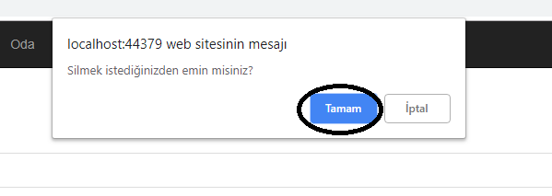

*Figure 8:Delete Brand*

Select "Tamam" to delete the brand information and continue to the next screen.

# HOME PAGE -DISPLAYING ASSET

It is possible to click on a specific area of ​​the school floor plans and to get the inventory list of the room at that location.

First of all, the main block of the school should be selected. Then the floor number in that block is selected. Finally, the room in the image should be selected as shown below.

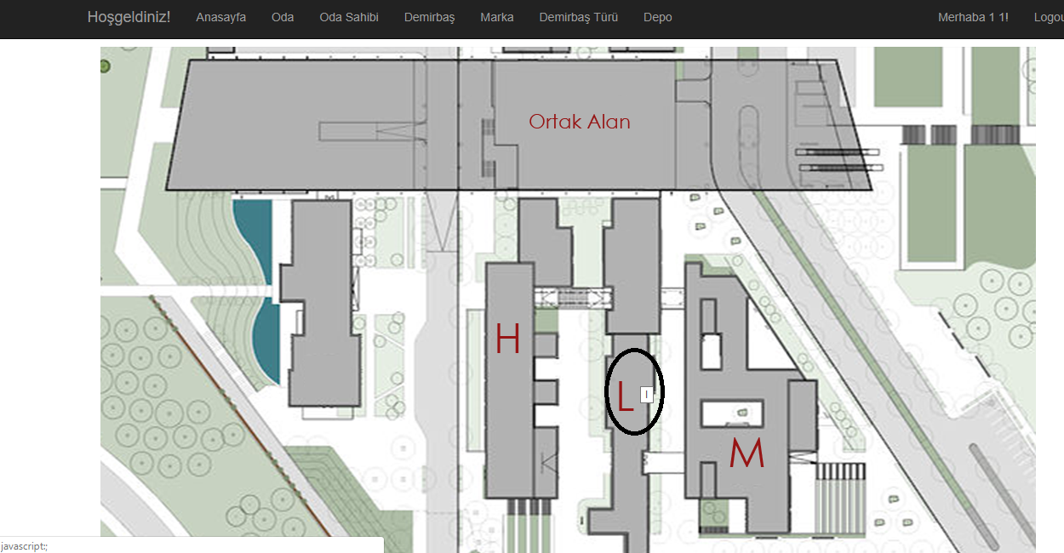

*Figure 9:Select the Block*

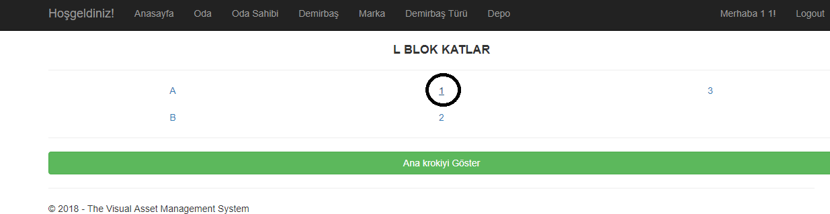

*Figure 10: Select the Floor*

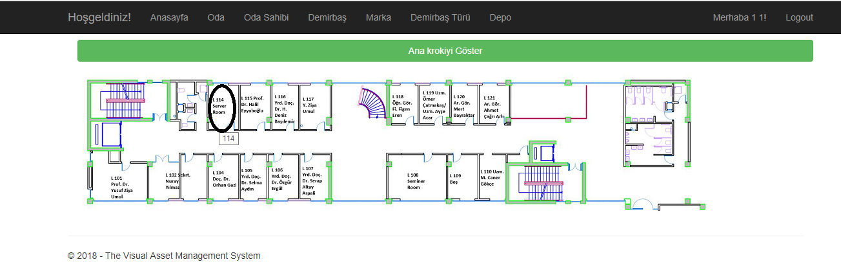

*Figure 11: Select the room*

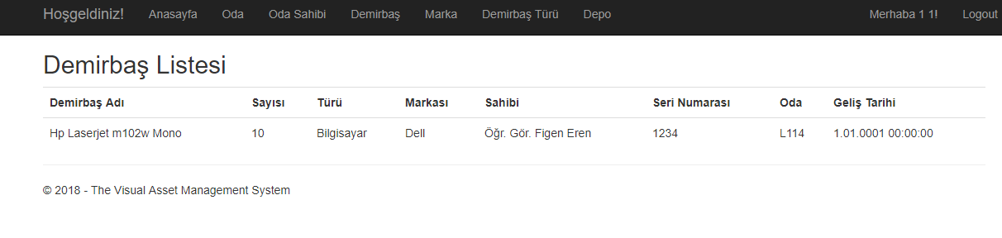

*Figure 12: The list of all assets will be displayed by the Visual Asset Management System.*

# LOGOUT

All of the users can succesfully logout with the logout button on the Panel of their Page.